BOBBY’S RUN SCHOOL SUPPLY LIST -2nd Grade

For the 2023-24 school year, students will keep belongings in their desk/cubby. Wheeled backpacks are not allowed.

Outside of the normal supplies which are received in the classroom, we are asking each student to bring the following items with them to school each day they come. Please make sure that your student’s belongings are labeled with their​ first and last name. As always, this is a suggested list.

Item | Quantity
Expo Dry Erase Marker 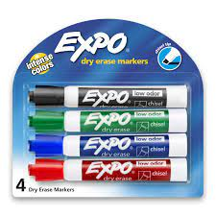 | 4
Mouse to use with student Chromebook 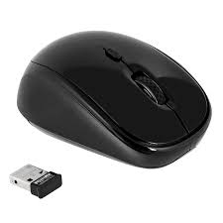 | 1
Headphones (earbuds break easily) 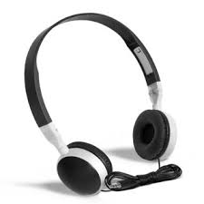 | 1 set
Plastic folder (yellow) 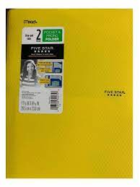 | 1
Plastic Folders (blue) 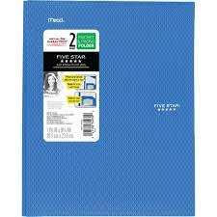 | 1
Crayons 24 pack 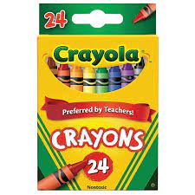 | 1
Glue Sticks 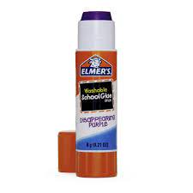 | 4
Colored pencils 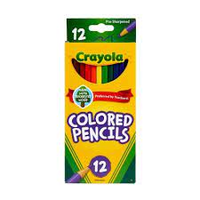 | 1

BOBBY’S RUN SCHOOL SUPPLY LIST -3rd Grade

For the 2023-24 school year, students will keep belongings in their desk/cubby. Wheeled backpacks are not allowed.

Outside of the normal supplies which are received in the classroom, we are asking each student to bring the following items with them to school each day they come. Please make sure that your student’s belongings are labeled with their​ first and last name. As always, this is a suggested list.

Item | Quantity
Medium/large backpack labeled with student’s name | 1
Mouse to use with student Chromebook | 1
Personal earbuds or headset for Chromebook (with microphone preferred) | 1
Crayons | 1 pack
School scissors (rounded edges, please) | 1
Glue sticks | 4
Binder (1 inch) | 1
Expo/dry erase markers | 6
Ticonderoga pencils | 24 pencils
Large pencil case/pouch | 1
Post its, 3x3, any color | 5 pads
6x9 index cards with lines | 1 pack
Composition notebooks- 100 pages each (no spiral notebooks, please) | 5
Two - pocket folders (all different colors/patterns) | 6 (1 per subject)
Reusable Water Bottle | 1

BOBBY’S RUN SCHOOL SUPPLY LIST -4th Grade

For the 2023-24 school year, students will keep belongings in their desk/cubby. Wheeled backpacks are not allowed.

Outside of the normal supplies which are received in the classroom, we are asking each student to bring the following items with them to school each day they come. Please make sure that your student’s belongings are labeled with their​ first and last name. As always, this is a suggested list.

4th Grade
Item | Quantity
Medium/large backpack labeled with student’s name (no wheels) | 1
Mouse to use with student Chromebook | 1
Personal earbuds or headphones for Chromebook (with microphone preferred) | 1
Large zippered pencil pouch | 1
100 page wide ruled composition notebook | 2
Wide Ruled one-subject notebook | 3
5 Folders (red, blue, yellow, green, purple) | 1 of each color
Pack of colored pencils | 1
Black Sharpie | 1
12-24 pack of yellow #2 pencils | 1
gluestick | 1
Pack of thin BLACK Expo markers (minimum 4 pack) | 1
3 pack of 3 x 3 Post-Its | 3

BOBBY’S RUN SCHOOL SUPPLY LIST -5th Grade

For the 2023-24 school year, students will keep belongings in their desk/cubby. Wheeled backpacks are not allowed.

Outside of the normal supplies which are received in the classroom, we are asking each student to bring the following items with them to school each day they come. Please make sure that your student’s belongings are labeled with their​ first and last name. As always, this is a suggested list.

Item | Quantity
Medium/large backpack labeled with student’s name | 1
Mouse to use with student Chromebook | 1
Personal earbuds or headset for Chromebook (with microphone preferred) | 1
Binder that zippers | 1
Crayons | 1 pack
Colored pencils | 1 pack
Markers | 1 pack
Black Sharpie | 1
Gluestick | 1
Sharpened, yellow # 2, pencils | 1 pack
Composition book or 1 subject notebook  (writer’s notebook) | 1
5 Subject Notebook | 1
3x3 post its - any color | 5 large packs
Pencil Sharpener | 1
Large, zippered pencil pouch with 3 holes (to fit in binder) | 1
Thin Expo/Dry erase markers | 1 Pack (4 count)
Folders (for all subjects) red, green, yellow, blue, your choice | 5

Ms. Every-Clayton’s Class GRADES 4,5

For the 2023-24 school year, students will keep belongings in their desk/cubby. Wheeled backpacks are not allowed.

Outside of the normal supplies which are received in the classroom, we are asking each student to bring the following items with them to school each day they come. Please make sure that your student’s belongings are labeled with their​ first and last name. As always, this is a suggested list.

Item | Quantity
Medium/large backpack labeled with student’s name | 1
Mouse to use with student Chromebook | 1
Personal earbuds or headset for Chromebook | 1
Sharpened pencils | 2-4
Composition or 1 Subject notebook | 4
Crayon | 1 pack
Markers | 1 pack
expo/ dry erase marker | 1
Pencil box | 1
Gluestick | 1

Mrs. Crugnale’s Class GRADES 2,3

For the 2023-24 school year, students will keep belongings in their desk/cubby. Wheeled backpacks are not allowed.

Outside of the normal supplies which are received in the classroom, we are asking each student to bring the following items with them to school each day they come. Please make sure that your student’s belongings are labeled with their​ first and last name. As always, this is a suggested list.

Item | Quantity
Medium/large backpack labeled with student’s name | 1
Headphones for Chromebook | 1
Colored pencils | 1
24 pack crayons | 1
Glue sticks | 4
Sharpened pencils | 2-4

Mrs. Clark’s Class GRADES 3, 4, 5

Item | Quantity
Medium/large backpack labeled with student’s name | 1
Mouse to use with student Chromebook | 1
Personal earbuds or headphones for Chromebook | 1
2 pocket folder | 2
Crayola Crayons | 1 pack
Crayola Markers | 1 pack
Gluestick | 1
Sharpened pencils | 2-4
Notebook (spiral or composition) | 1
Pencil Case | 1

